**UNIVERSITI TEKNOLOGI MARA CAWANGAN PERAK**

**KAMPUS TAPAH**

**INDUSTRIAL TRAINING REPORT**

**DC TECHNOLOGY SOLUTIONS SDN. BHD.**

**INDUSTRIAL TRAINING REPORT**

**AT**

**DC TECHNOLOGY SOLUTIONS SDN. BHD.**

**LEVEL 12, MENARA LGB NO.1, JALAN WAN KADIR TAMAN TUN DR. ISMAIL, 60000 KUALA LUMPUR, MALAYSIA**

**BY**

**AHMAD SUFFIAN BIN MUHAMMAD SHAHRIL (2021494474)**

**FACULTY OF COMPUTER AND MATHEMATICAL SCIENCES (FSKM)**

**BACHELOR OF COMPUTER SCIENCE (HONS.) (CS230)**

**JANUARY 2025**

i

**SUPERVISOR APPROVAL**

**INDUSTRIAL TRAINING REPORT**

By

**AHMAD SUFFIAN BIN MUHAMMAD SHAHRIL**

**2021494474**

This industrial training report was completed under the guidance of the industrial training supervisor, Ahmad Fadli bin Saad (Dr.). It was submitted to the Faculty of Computer and Mathematical Sciences (FSKM) and accepted as partial fulfilment of the requirements for the Bachelor of Computer Science (Hons.) degree.

Approved by

…………………………………

AHMAD FADLI BIN SAAD (DR.)

Industrial Training Supervisor

JANUARY 10, 2025

i

**ACKNOWLEDGEMENT**

Alhamdulillah, all praise be to Allah SWT. With His infinite grace and blessings, I was able to successfully complete my industrial training report within the allotted time. Firstly, I would like to express my heartfelt gratitude to my supervisor, Mr. Yuen Fei Goh, and my project manager, Mr. Deepak Hiremath, for their invaluable guidance and knowledge throughout this experience. Their support provided me with meaningful opportunities to create practical, real-world projects that serve as realistic simulations and learn during my industrial training period.

I would also like to extend my sincere appreciation to my CST688 (Industrial Training) lecturer, Dr. Nursyahidah Binti Alias, for her unwavering support and guidance from the start of my internship until its completion. Special thanks as well to my industrial training supervisor, Dr. Ahmad Fadhli Bin Saad, for his insightful advice, encouraging words, and guidance on how to adapt and excel in a workplace environment, which helped me strive to be the best trainee I could be.

My deepest gratitude also goes to my family for their constant encouragement and support throughout my internship journey. Additionally, I am thankful to my friends and colleagues for their knowledge-sharing and cooperation, enabling all of us to successfully complete our internship period. Lastly, I would like to thank Deloitte ICDC Malaysia and all its staff for giving me the invaluable opportunity to gain experience in a prestigious organization.

ii

TABLE OF CONTENTS

iii

|  |  |
| --- | --- |
| **CONTENT**  **SUPERVISOR APPROVAL**  **ACKNOWLEDGEMENT**  **TABLE OF CONTENTS**  **LIST OF FIGURES**  **LIST OF TABLES**  **CHAPTER 1: INTRODUCTION**  1.1 Objective  1.2 Scope  1.3 Importance  1.4 Conclusion  **CHAPTER 2: ORGANIZATIONAL BACKGROUND**  2.1 Introduction  2.2 Deloitte’s Philosophy  2.3 Deloitte’s Logo  2.4 Deloitte’s Location  2.5 Deloitte’s Website  2.6 ICDC Deloitte’s Team  **CHAPTER 3: PRIMARY TASK (E-LEARNING PLATFORM)**  3.1 Introduction  3.2 Problem Statements  3.3 OpenLearnHub  3.4 Objectives  3.5 Scope  3.6 Implementation  3.6.1 Planning Phase  3.6.2 Design Phase  3.6.3 Development and Testing Phase  3.6.4 Deployment Phase  3.7 Results and Discussion  3.8 User Interface  3.9 Summary  **CHAPTER 4: PRELIMINARY TASK**  4.1 Tasks and Assignments  4.1.1 Mandatory E-Learning (Deloitte)  4.1.2 Technical Learning Path  **CHAPTER 5: CONCLUSION**  5.1 Benefits of Internship  5.2 Recommendations and Improvements  **APPENDICES** | **PAGE**  i  ii  iii  v  vi  1  2  2  2  3  3  4  4  5  6  8  8  9  10  10  11  11  12  13  14  14  15  17  18  18  19  21  22  24 |

iv

**LIST OF FIGURES**

|  |  |
| --- | --- |
| **FIGURE**  2.1 Deloitte’s Logo  2.2 Deloitte’s Location  2.3 Deloitte’s Malaysia Official Website  3.1 ERD of OpenLearnHub  3.2 System Architecture of OpenLearnHub  3.3 Home Page  3.4 Enrolled Course Page  3.5 Course Dashboard Page  3.6 Edit Course Page  4.1 Technical Learning Path | **PAGE**  4  5  5  12  13  15  16  16  16  20 |

v

**LIST OF TABLES**

|  |  |
| --- | --- |
| **TABLE**  2.1 General Information of Organization | **PAGE**  6 |

vi

# **CHAPTER ONE**

**INTRODUCTION**

An internship is a program created to help students bridge the gap between academic knowledge and practical applications through providing them practical experience in their field of study. It also gives students the opportunity to learn vital skills, learn company practices, and operate in a professional environment.

Moreover, this exposure helps students build confidence, enhance their problem-solving skills, and establish valuable industry connections. Internships also allow students to explore potential career paths, enabling them to make informed decisions about their future.

## **1.1 Objective**

The purpose of internships is to help students develop into capable professionals by giving them exposure to the real world and practical skills. Students are better prepared for their future employment by participating in practical assignments that provide them an understanding of job duties and industry expectations. The internship program's goals for students are as follows:

* To provide practical experience in their field of study.
* To develop professional skills, such as communication, teamwork, and problem-solving.
* To expose students to industry standards, practices, and tools.
* To enhance their understanding of workplace ethics and responsibilities.
* To enable students to apply theoretical knowledge in real-world scenarios.
* To build a professional network that could support their future career growth.

## **1.2 Scope**

The job experiences and knowledge acquired throughout the internship time are the main topics of this internship report. It highlights the duties and responsibilities given, the abilities gained, and how the internship affected the intern's capability to advance professionally. The scope is limited to the work completed and the projects started during the internship.

## **1.3 Importance**

Internships play a crucial role in bridging the gap between academic knowledge and the demands of the professional world. They offer students a chance to grow personally and professionally, enabling them to make informed career decisions. The importance of internships for students includes:

* Enhancing employability by gaining relevant work experience.
* Bridging the gap between academic learning and practical application.
* Providing insights into industry trends and expectations.
* Helping students identify their strengths and areas for improvement.
* Offering opportunities to build a professional network.
* Preparing students for the transition from academics to the workforce.

## **1.4 Summary**

Thus, internships are an essential component of both professional and academic growth. They give students the opportunity to obtain practical experience, develop critical abilities, and get prepared for their future employment. To lay the groundwork for the in-depth examination of the internship experience in the next chapters, this chapter has provided an overview of the significance, objectives, scope, and importance of internships.

**CHAPTER TWO**

**ORGANIZATIONAL BACKGROUND**

This chapter outlines Deloitte Malaysia and its Innovation & Cloud Development Centre (ICDC), emphasizing innovation, sustainability, and excellence. Based in Menara LGB, Kuala Lumpur, the ICDC focuses on AI, cloud computing, and software engineering, fostering collaboration and mentoring to develop cutting-edge solutions.

**2.1 Introduction**

Global professional services firm Deloitte is well-known for its expertise in advisory, tax, audit, and consulting services. The company is committed to promoting purpose-driven growth, innovation, and diversity. Deloitte is committed to making a significant difference by offering innovative solutions and encouraging excellence among its employees. It is essential for dealing with important global problems and advancing healthy corporate practices.

**2.2 Deloitte’s Philosophy**

The foundation of Deloitte's philosophy is its primary goal which is to have a meaningful effect. The values of sustainability, innovation, and openness serve as the organization's direction. Deloitte seeks to address social problems, promote fair corporate practices, and encourage purpose-driven growth for its clients and communities through its WorldImpact programs. These principles demonstrate their commitment to developing a supportive work environment that promotes diversity and fosters creativity.

**2.3 Deloitte’s Logo**

The name "Deloitte" stands out beside a characteristic green dot in the bold and contemporary design of the Deloitte logo. The three main principles that guide Deloitte's international initiatives, which are growth, sustainability, and innovation, are represented by this green dot. The logo's simplicity presents a professional and forward-thinking image, which matches Deloitte's track record of providing innovative solutions and making a lasting impression on the world stage. The Deloitte logo is displayed in Figure 2.1.

**Figure 2.1** Deloitte’s Logo

Moreover, the Deloitte logo, which is well-known in a variety of industries, stands for excellence, professionalism, and trust. It’s clear, modern design expresses confidence and clarity, and the eye-catching green dot represents the company's focus on expansion and sustainability. This striking design is in line with Deloitte's mission to make significant contributions by showcasing the company's commitment to innovation and vision for a brighter future.

**2.4 Deloitte’s Location**

The headquarters of Deloitte Malaysia are in the upscale LGB Tower in Taman Tun Dr. Ismail (TTDI), Kuala Lumpur. The company can effectively serve clients throughout Malaysia and the larger Asia-Pacific area because of its strategic position. With the latest technologies that encourage teamwork and the creation of cutting-edge technical solutions, the Kuala Lumpur office is renowned for its creative and cooperative atmosphere. Deloitte Malaysia's location is shown in Figure 2.2.

**Figure 2.2** Deloitte’s location at LGB Tower, situated in TTDI, Kuala Lumpur

Furthermore, Level 7 of the LGB Tower is home to the Innovation & Cloud Development Centre (ICDC). By using a hot-desking concept, the centre gives staff members and interns the freedom to choose their own sitting layouts. This strategy creates a vibrant and stimulating work environment that values cooperation and flexibility.

**2.5 Deloitte’s Website**

The primary resource for learning about Deloitte Malaysia's offerings, perspectives, and employment prospects is the company's official website, www2.deloitte.com/my/en.html. The website, which highlights professionalism and accessibility, demonstrates Deloitte's dedication to providing value to stakeholders and clients. A preview of the homepage is shown in Figure 2.3, which highlights the company's commitment to promoting innovation and purpose-driven advancement.

**Figure 2.3** Deloitte Malaysia Official Website

Additionally, it serves as a stage for presenting Deloitte's innovative tactics and their effects on a range of industries. Interactive elements give customers a better grasp of Deloitte's numerous offerings and current projects, which reflects the company's emphasis on openness and long-term development.

**2.6 ICDC Deloitte Team**

The goal of Deloitte's Innovation & Cloud Development Centre (ICDC) is to develop advanced technologies in artificial intelligence, cloud computing, and software engineering. It is essential in helping customers by providing them with innovative tools and strategies that promote company growth and operational effectiveness. The team places a strong emphasis on creating innovative approaches that combine the newest technology developments and industry best practices.

Team members at ICDC actively mentor interns, giving them real-world experience to address real-world problems in the tech sector. This mentorship creates a supportive and cooperative environment that helps interns gain confidence and vital skills for their future careers.

**Table 2.1** General Information of Organization

|  |  |
| --- | --- |
| **Name** | Deloitte Malaysia |
| **Branch** | Kuala Lumpur (Malaysia Headquarter) |
| **Department** | Innovation & Cloud Development Centre (ICDC) |
| **Vision and Mission** | We aspire to be the Standard of Excellence, the first choice of the most sought-after clients and talent to help our clients and people excel. |
| **Operating Hours** | 8.30 am – 5.30 pm |
| **Location** | Menara LGB, Level 7, Jalan Wan Kadir, Taman Tun Dr Ismail, 60000 Kuala Lumpur |
| **Contact number** | 03-7610-8888 |
| **Website URL** | https://www2.deloitte.com/my/en.html |

Moreover, the goals of the Innovation & Cloud Development Centre are to create software solutions that are customised for clients, improve cloud engineering and DevOps procedures for optimal performance, and apply AI and machine learning technologies to improve decision-making. It also aims to create a cooperative atmosphere that encourages innovation and creativity among team members.

**CHAPTER THREE**

**PRIMARY TASK (E-LEARNING PLATFORM)**

This chapter outlines the development process of the OpenLearnHub e-learning platform, focusing on the planning, design, development, and deployment phases. The platform was built using React with TypeScript and Firebase to provide a user-friendly, scalable experience for both students and instructors. Key challenges included mastering Redux and enhancing file upload functionalities, while future improvements will focus on better tracking of student progress and file management.

**3.1 Introduction**

The tasks that are performed in industrial training are very different from those that are performed in academic settings. Tasks are useful assignments assigned to people or groups in an industrial context that must be finished within a predetermined amount of time. During my internship, the main task during the training period was creating an online learning platform. Students can explore and sign up for a variety of courses on this platform, while instructors can create and manage course materials.

**3.2 Problem Statements**

One of the problems is that there are difficulties in creating an e-learning platform, especially when it comes to satisfying the demands of students as well as instructors. While instructors need effective tools to develop and manage content like lessons and quizzes, students need a straightforward interface to explore, enrol in, and track courses. It is crucial to strike a balance between these demands while maintaining an accessible and user-friendly experience.

Moreover, giving instructors a dedicated course dashboard to manage their materials while allowing them to quickly add documents, quizzes, and videos to courses presents another difficulty. To ensure a smooth content development process, this dashboard should provide instructors with an easy-to-use interface for organising, editing, and updating their course materials.

Furthermore, addressing varying levels of technological literacy among users is crucial. Both students and instructors may have different levels of comfort and experience with digital tools. Designing an intuitive and straightforward interface that accommodates these differences is vital to ensure that all users can effectively navigate and utilize the platform without facing unnecessary obstacles.

**3.3 OpenLearnHub**

OpenLearnHub is a free-to-use e-learning platform designed to provide accessible education for all users. The platform offers a wide range of courses across various subjects, allowing students to enrol in any course without any cost. With its user-friendly interface, OpenLearnHub makes it easy for students to browse through available courses and learn at their own pace.

In addition, instructors can also contribute by creating and sharing their own courses, enriching the platform with diverse educational content. OpenLearnHub aims to make learning more accessible, providing quality educational resources without financial barriers, and fostering a community of learners and instructors committed to personal and professional growth.

**3.4 Objectives**

The primary goal of this e-learning platform is to provide an accessible and efficient solution for both students and instructors. By leveraging modern technologies, the platform aims to address the challenges of usability, scalability, and functionality, ensuring a seamless experience for all users. The following objectives outline the key focus areas in the development process:

* To investigate the best methods and practices for implementing the front end using React with TypeScript and the back end using Firebase.
* To create a user-friendly interface for course enrolment and management.
* To develop a scalable platform that supports both students and instructors efficiently.

**3.5 Scope**

The scope of this e-learning platform encompasses features tailored for both students and instructors, ensuring an inclusive and functional experience. For students, the platform offers free access to a wide range of courses, enabling them to explore and enrol in courses with ease. Instructors, on the other hand, are provided with tools to create, manage, and update course content, including lessons, quizzes, and multimedia materials. The platform is designed to be scalable and compatible across multiple devices, ensuring accessibility for all users while maintaining a user-friendly interface and efficient performance.

**3.6 Implementation**

The implementation of the e-learning platform was carried out in four key phases: planning, design, development and testing, and deployment. Each phase focused on defining the goals, designing the user interface, building, and testing core features, and finally deploying the platform for real-world use. The following sections will explain each phase in detail.

### **3.6.1 Planning Phase**

The planning phase focused on defining the project’s primary goals, including creating a user-friendly interface for students and instructors, ensuring scalability, and providing an effective content management system for instructors. After evaluating various technologies, React with TypeScript was selected for the front-end due to its scalability and type-safety features, while Firebase was chosen for the back-end for its real-time database capabilities and seamless integration. These decisions laid a strong foundation for the platform’s development.

The project followed a structured timeline with milestones: research and design (1 week), development (8 weeks), testing (1 week), and deployment (1 week). Using the Agile methodology, the team conducted weekly sprints and check-ins to monitor progress and address challenges. Key diagrams, such as the Entity-Relationship Diagram (ERD) and Activity Diagram, were developed to visualize the platform’s structure and user interactions, ensuring alignment on the system’s architecture and goals.

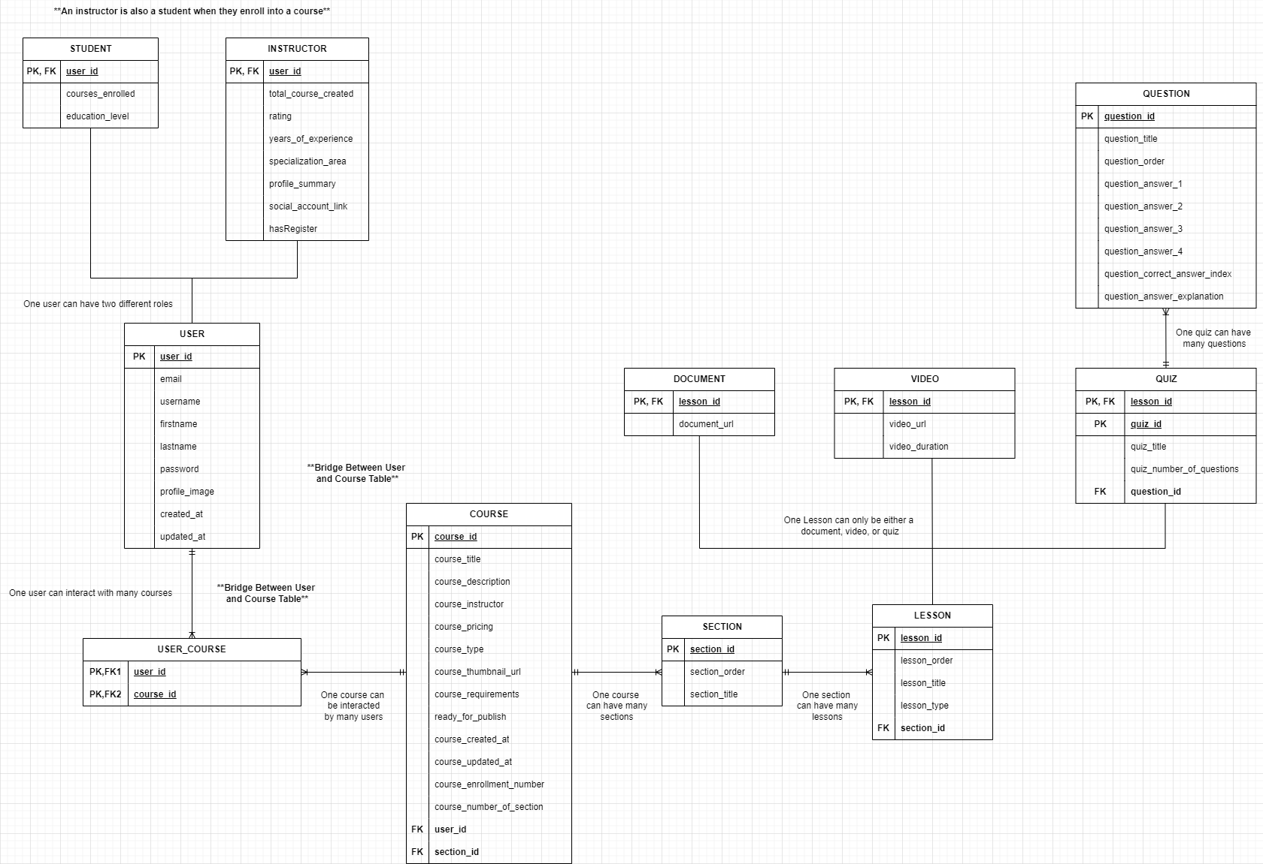

**Figure 3.1** ERD of OpenLearnHub

### **3.6.2 Design Phase**

During the design phase, wireframes were created to visualize the platform’s layout, focusing on key pages such as the Home Page, Course Enrolled Page, Course Dashboard Page, and Create or Edit Course Page. The instructor dashboard was designed to streamline navigation with sections for managing and creating courses. A system architecture diagram was also developed to illustrate the interaction between the front-end (React with TypeScript and React-Redux), the back-end (Firebase), and deployment tools such as Vercel and Podman, ensuring seamless performance and scalability.

The database schema was structured to include collections for Users and Courses. The Users collection stores details like names, emails, and roles (student or instructor), while the Courses collection includes metadata such as titles and descriptions. Additionally, two activity diagrams were created: one for students, mapping out their flow from selecting to enrolling in a course, and another for instructors, detailing the steps for creating and managing courses. These designs provided a robust framework for the platform’s functionality and user experience.

### **3.6.3 Development and Testing Phase**

The development phase focused on implementing core components using React and TypeScript, with Tailwind CSS ensuring a responsive user interface. Essential features, such as the CourseDashboard, CourseContentList, and ProfileView, were designed to support both student and instructor roles effectively. Firebase was used for user authentication and data storage, while React-Redux streamlined state management to ensure smooth functionality across the platform.

Testing concentrated on functionality and responsive design. React components were tested with Jest to confirm performance, and the interface was optimized for various screen sizes. Feedback from the development team during iterative testing cycles guided improvements to features like course creation and browsing, ensuring the platform met usability and performance expectations.

**Figure 3.2** System Architecture of OpenLearnHub

### **3.6.4 Deployment Phase**

During the deployment phase, the e-learning platform was hosted using Vercel, which provided seamless integration with React applications and enabled continuous deployment. This ensured that any changes pushed to the repository were automatically built and deployed, streamlining the development process. Additionally, Podman was utilized for containerization, allowing the application to maintain consistent environments across development and production. This approach facilitated scalability and simplified updates or future feature additions.

The platform's state management was integrated with React-Redux, ensuring a consistent and efficient user experience, particularly for actions such as course enrolment and dashboard interactions. After deployment, rigorous testing was conducted in the live environment to verify the platform’s stability and performance. The team ensured that the user interface and backend services, including authentication and data retrieval, operated smoothly under real-world conditions.

**3.7 Results and Discussion**

The e-learning platform effectively provided a user-friendly experience for both students and instructors. Students were able to easily explore and enrol in courses, while instructors successfully managed and updated course content. The system operated smoothly in the live environment, with no significant issues. The platform's responsive design ensured accessibility across small laptop screens and monitors, making it convenient for users to interact with the platform regardless of their device.

A key challenge was understanding and implementing Redux for state management. The learning curve was steep, but through collaboration and testing, the team streamlined Redux to handle state changes effectively. This ensured consistent data flow and improved the overall platform performance, making the management of large-scale applications more efficient.

Future improvements include enabling direct file and video uploads, reducing reliance on external sources like YouTube or web images. Additionally, tracking students' progress within courses would enhance personalization and engagement, giving both students and instructors better control over the learning process.

**3.8 User Interfaces**

The user interface of OpenLearnHub features various pages catering to both students and instructors. From the student's side, the Home Page and Enrolled Course Page provide easy navigation and course management. On the instructor's side, the Course Instructor Dashboard allows seamless content management, while the Create or Edit Course Page offers an intuitive interface for creating and editing courses. These pages work together to provide a smooth and efficient experience for both user groups.

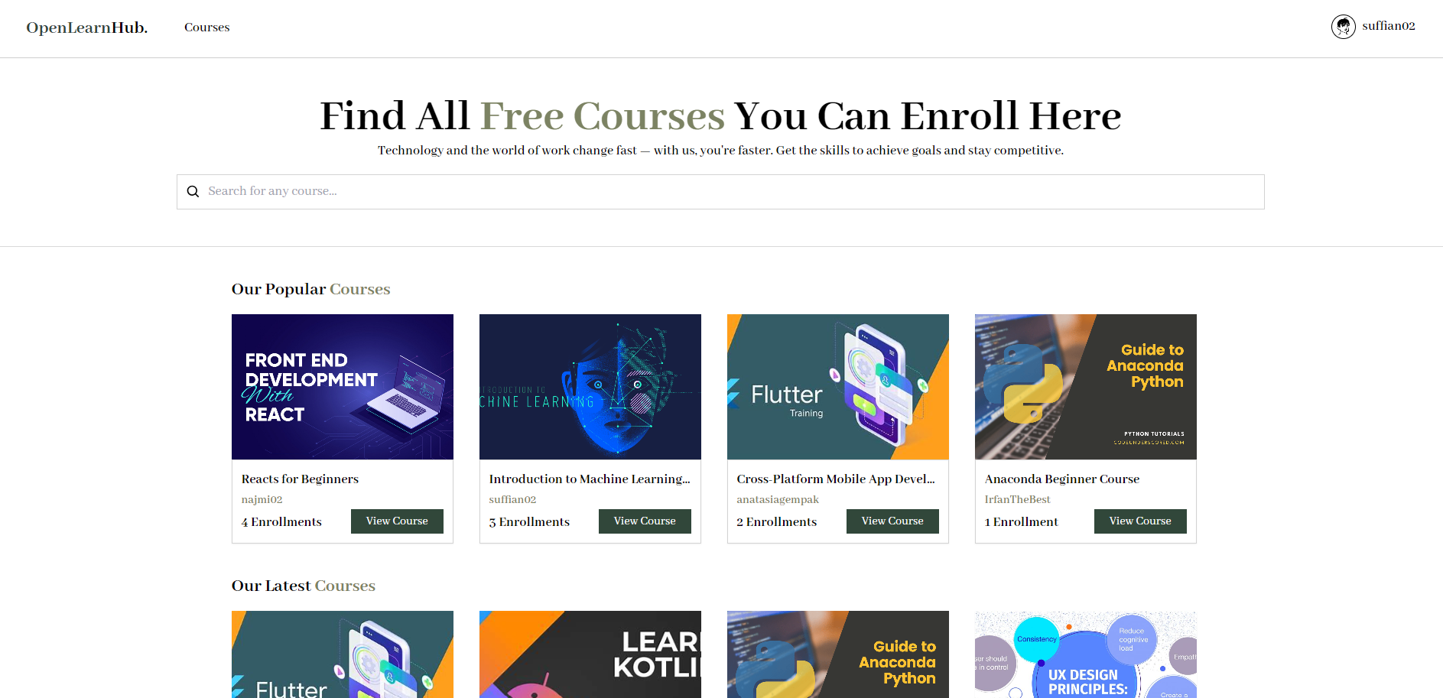

**Figure 3.3** Home Page

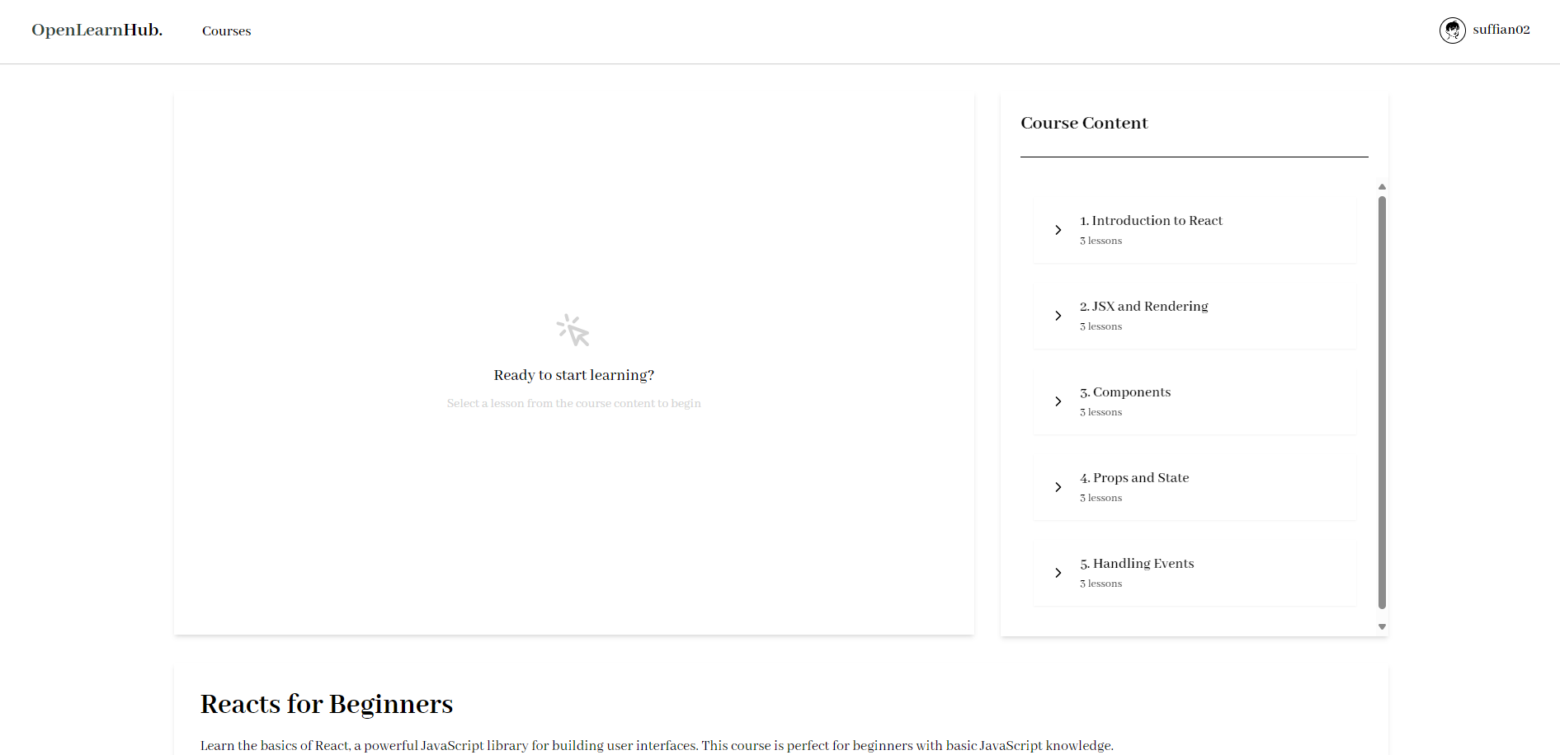

**Figure 3.4** Enrolled Course Page

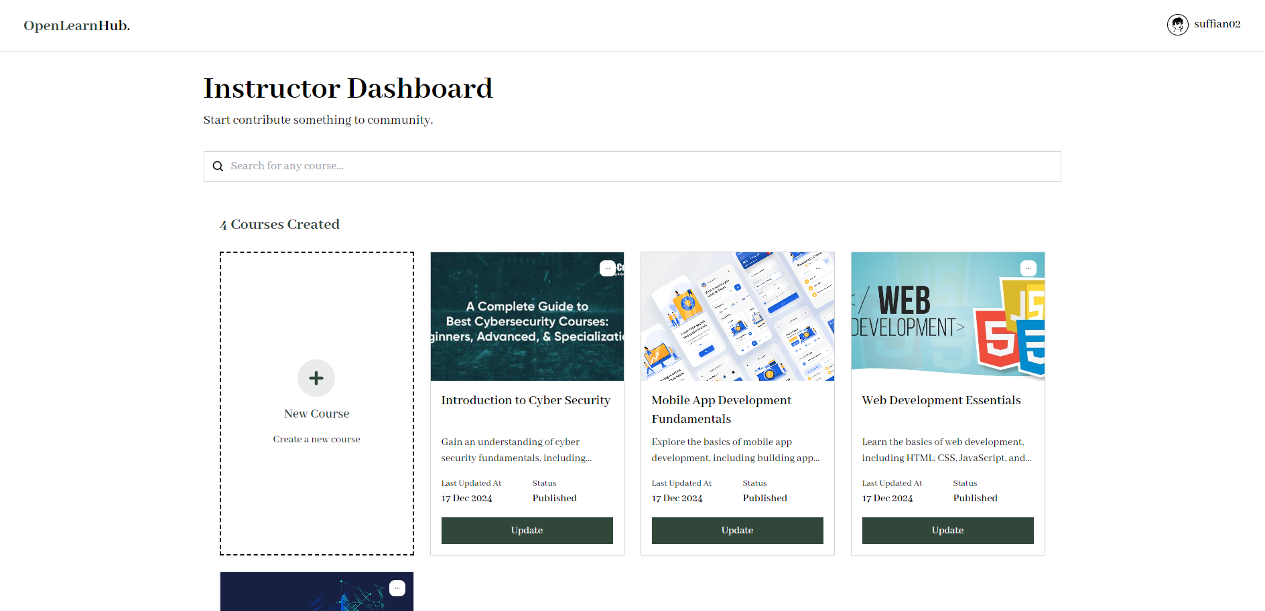

**Figure 3.5** Course Dashboard Page

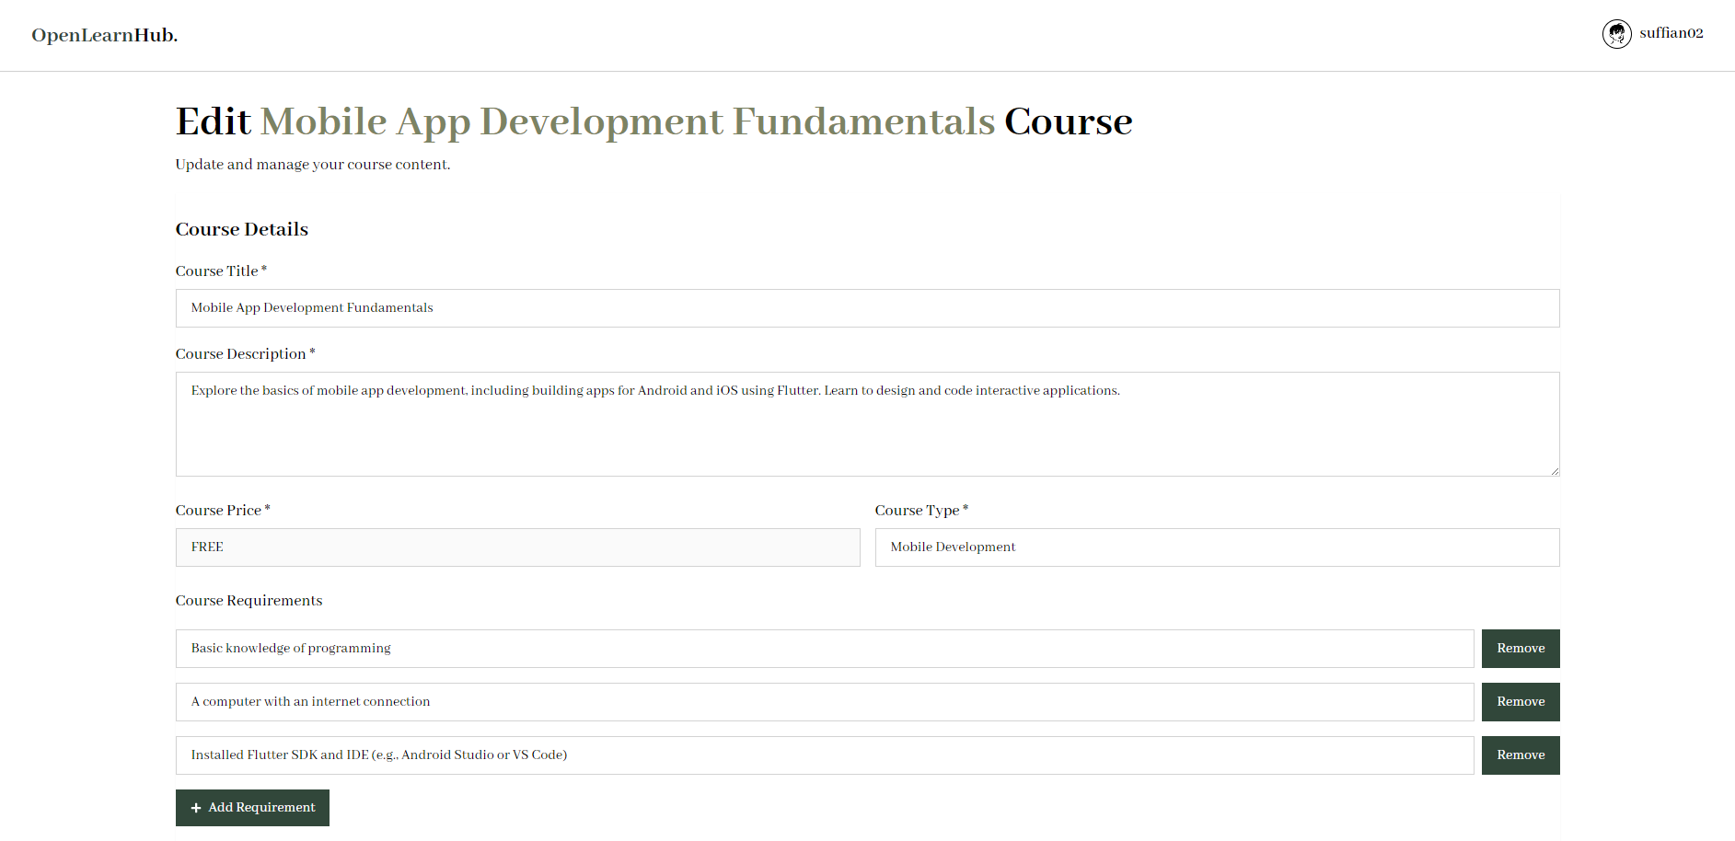

**Figure 3.6** Edit Course Page

**3.9 Summary**

In conclusion, the development of the OpenLearnHub e-learning platform successfully addressed the needs of both students and instructors. By utilizing React with TypeScript for the front-end and Firebase for the back-end, the platform provides an intuitive, scalable, and responsive solution for course enrolment, management, and content creation. Despite challenges in mastering Redux and file management, the platform has shown strong performance, ensuring an effective learning environment. Future improvements will focus on enhancing file upload features and better tracking of student progress.

# **CHAPTER FOUR**

**PRELIMINARY TASKS**

This chapter focuses on the tasks and assignments completed, which included mandatory Deloitte e-learning courses and self-learning path sessions on front-end and back-end technologies. These tasks were designed to provide essential knowledge and skills, preparing us for the main project of developing the e-learning platform. The e-learning courses and technical sessions laid a solid foundation, helping us get ready for the hands-on development work ahead.

## **4.1 Tasks and Assignments**

Tasks and assignments in general were focused on building the necessary skills and knowledge required for the main project. For this section, it specifically highlights the tasks and assignments completed during the first week, which included the mandatory Deloitte e-learning courses and self-learning path sessions. These tasks were designed to provide essential knowledge and skills that laid the foundation for the main project. The e-learning sessions were crucial in preparing for the development of the e-learning platform, ensuring a smooth transition to the primary task.

### **4.1.1 Mandatory E-Learning (Deloitte)**

The mandatory Deloitte e-learning courses are designed for all new employees, including interns and full-time hires, to ensure they are well-equipped with essential knowledge regarding the company's core values and expectations. These courses cover a wide range of topics, including ethics, anti-corruption, maintaining a good work environment, and mental health awareness. The purpose of these sessions is to promote a healthy, ethical, and productive workplace culture. New employees are required to complete these courses within the first two weeks of their employment, ensuring they understand and align with Deloitte’s principles from the start.

These e-learning modules are an integral part of onboarding at Deloitte, providing employees with the foundational knowledge needed to thrive in the organization. By focusing on morale, mental well-being, and ethical practices, the courses aim to prepare employees for challenges in the workplace and encourage them to contribute positively to a supportive and ethical company culture. Completing these mandatory tasks is essential before transitioning to the primary tasks related to specific projects, ensuring that employees have a comprehensive understanding of their roles and responsibilities within Deloitte.

**4.1.2 Technical Learning Path**

The technical learning path consists of self-directed learning sessions focused on front-end and back-end technologies, using materials provided through Udemy. As part of the internship, technology interns are required to complete these sessions during the first month. The front-end learning path involved taking a course on React JS, while the back-end learning path consisted of two courses. The first course was focused on the application environment, specifically Docker, and the second course covered back-end frameworks, with a focus on Spring Boot microservices and Spring Cloud.

For the front-end learning path, I began with a course titled “Master React and Redux. Apply modern design patterns to build apps with React Router, Tailwind CSS, Context, and Hooks!” This course was designed to provide hands-on experience by building simple projects and solving common errors encountered in React development. It also covered important concepts such as React Router, Tailwind CSS for styling, and React Hooks, which are key tools for modern React development.

The second course focused on Docker, a tool used for containerizing and deploying applications. I completed two Udemy courses to gain a better understanding of Docker’s capabilities and benefits. These courses included practical exercises such as using Docker commands for building images, running containers, deploying applications, and performing basic container maintenance. This practical experience was crucial in understanding how to manage project environments effectively.

Finally, I completed a course on Spring Boot, which is widely used for building Java-based web applications and microservices. This course focused on the key components necessary for developing RESTful web applications, including HTTP response validation, authentication, and the implementation of JWT tokens for secure user authentication. The course was highly hands-on, allowing me to build projects that reinforced my understanding of Spring Boot's capabilities for back-end development.

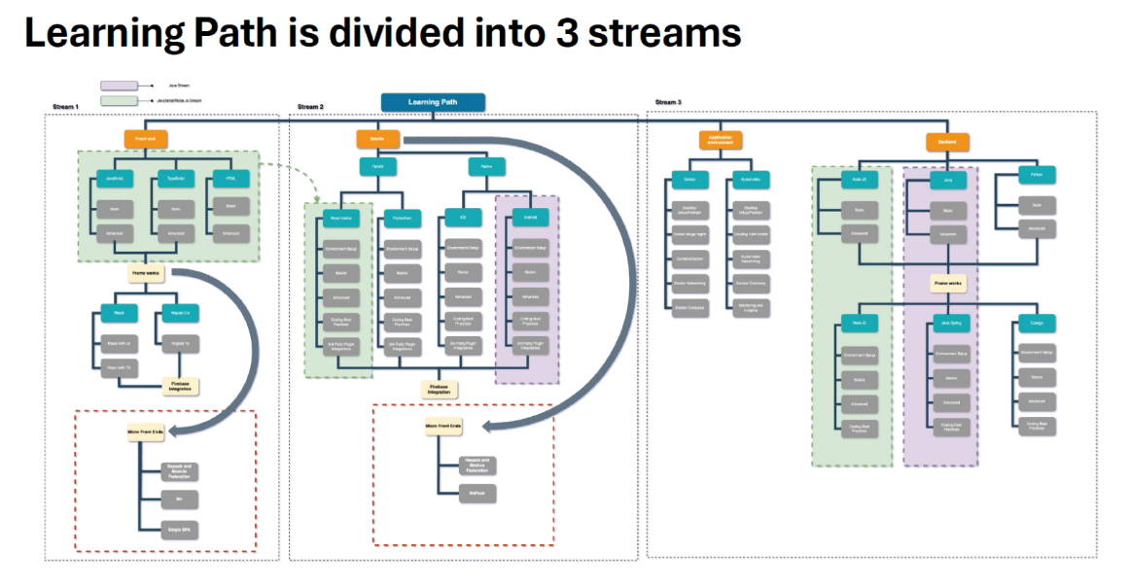

**Figure 4.1** Technical Learning Path

**CHAPTER FIVE**

**CONCLUSION AND RECOMMENDATION**

In this chapter, a detailed review and analysis of the Silat-AI project are explained, with a focus on its results and implications. It explores both successes and challenges faced during the phases of development and implementation, emphasizing the techniques used and the technological innovations included in the system. The results of each objective are combined in this chapter, which also discusses the development of an efficient classification model for Silat techniques and the accuracy of pose landmark detection algorithms. It also provides an evaluation of the system's performance metrics and user feedback, pointing out its weaknesses and making recommendations for future improvements.

## **5.1 Benefits of Internship**

During my internship, I gained the opportunity to learn a variety of new programming languages, frameworks, and tools that were directly applicable to the project. Courses on React JS, Docker, and Spring Boot provided me with in-depth knowledge of both front-end and back-end technologies. This learning was not only theoretical but also hands-on, as I was able to implement these technologies in the development of the e-learning platform. The experience reinforced my understanding and helped me gain confidence in using modern development frameworks to create real-world applications.

Moreover, the internship also provided invaluable exposure to real-world challenges that go beyond the classroom. Unlike academic projects, the issues I faced during this internship were more complex and required practical problem-solving skills. Working with a team, adapting to project changes, and meeting tight deadlines helped me navigate the pressures of real-world development. This experience enhanced my technical abilities and equipped me with critical thinking skills, preparing me for future professional challenges in the tech industry.

In addition to technical growth, the internship offered significant professional development opportunities. I had the chance to interact with mentors, colleagues, and fellow interns, gaining insights into the dynamics of the workplace and the tech industry. These interactions not only helped improve my teamwork, communication, and time management skills but also enabled me to build valuable professional connections. Networking within the company has provided me with support and guidance that will be beneficial for my career development moving forward.

## **5.2 Recommendations and Improvements**

For future improvements, I recommend enhancing the learning resources provided to interns by including more hands-on projects that mimic real-world scenarios. While the courses provided a solid theoretical foundation, additional practical tasks would allow interns to apply their knowledge in more diverse and complex settings. This could help build confidence and better prepare interns for the challenges they will face in professional environments.

Another recommendation is to improve the mentorship structure by providing more personalized guidance and feedback. While there were valuable learning opportunities throughout the internship, having more one-on-one sessions with mentors would allow for targeted advice on improving specific skills. This personalized support could help interns grow faster and address individual development needs more effectively.

Additionally, expanding the scope of the technical learning path to include more up-to-date frameworks and tools used in the industry would benefit future interns. Technologies evolve quickly, and staying current with the latest trends would ensure that interns are learning the most relevant and in-demand skills. Integrating newer tools and technologies into the curriculum would better align the learning experience with industry expectations.

**APPENDICES**

A: Mini Projects developed during Technical Learning Path (ReactJS)

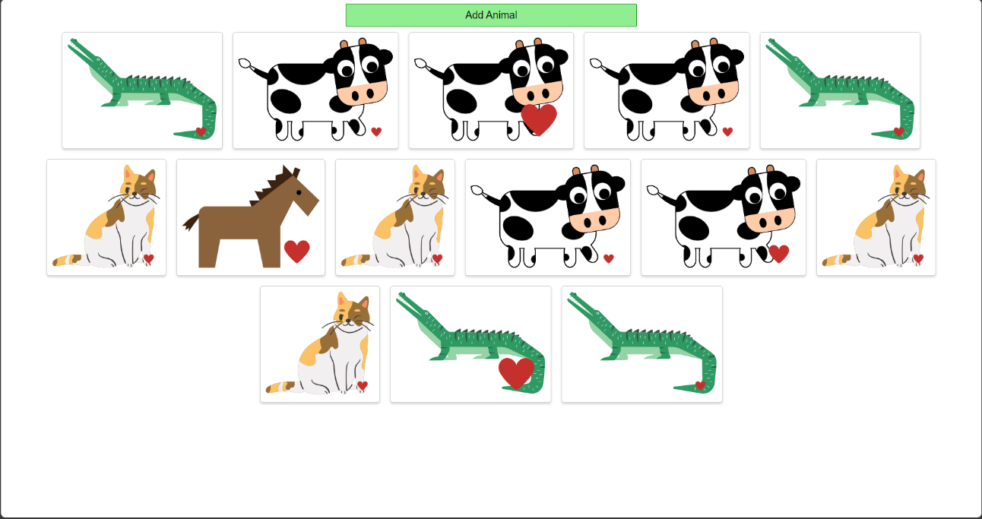

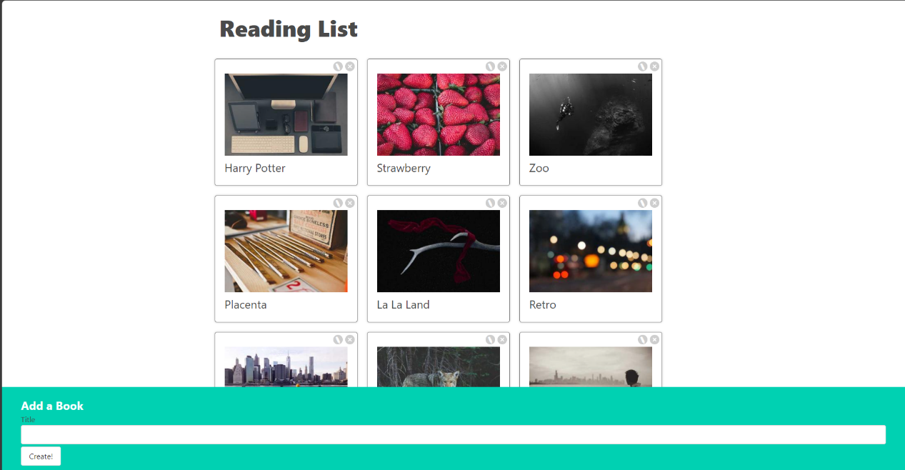

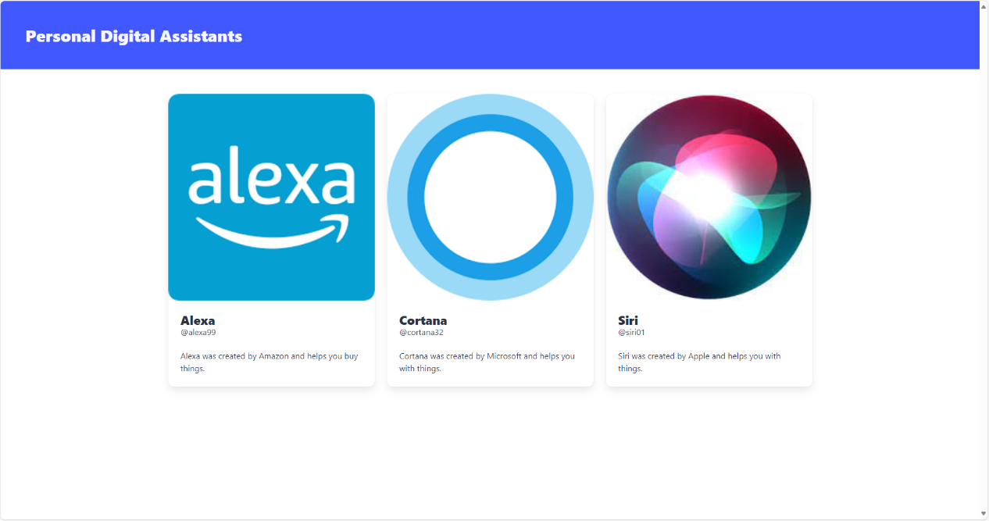

B: Microservices created during Technical Learning Path (Spring Boot)

